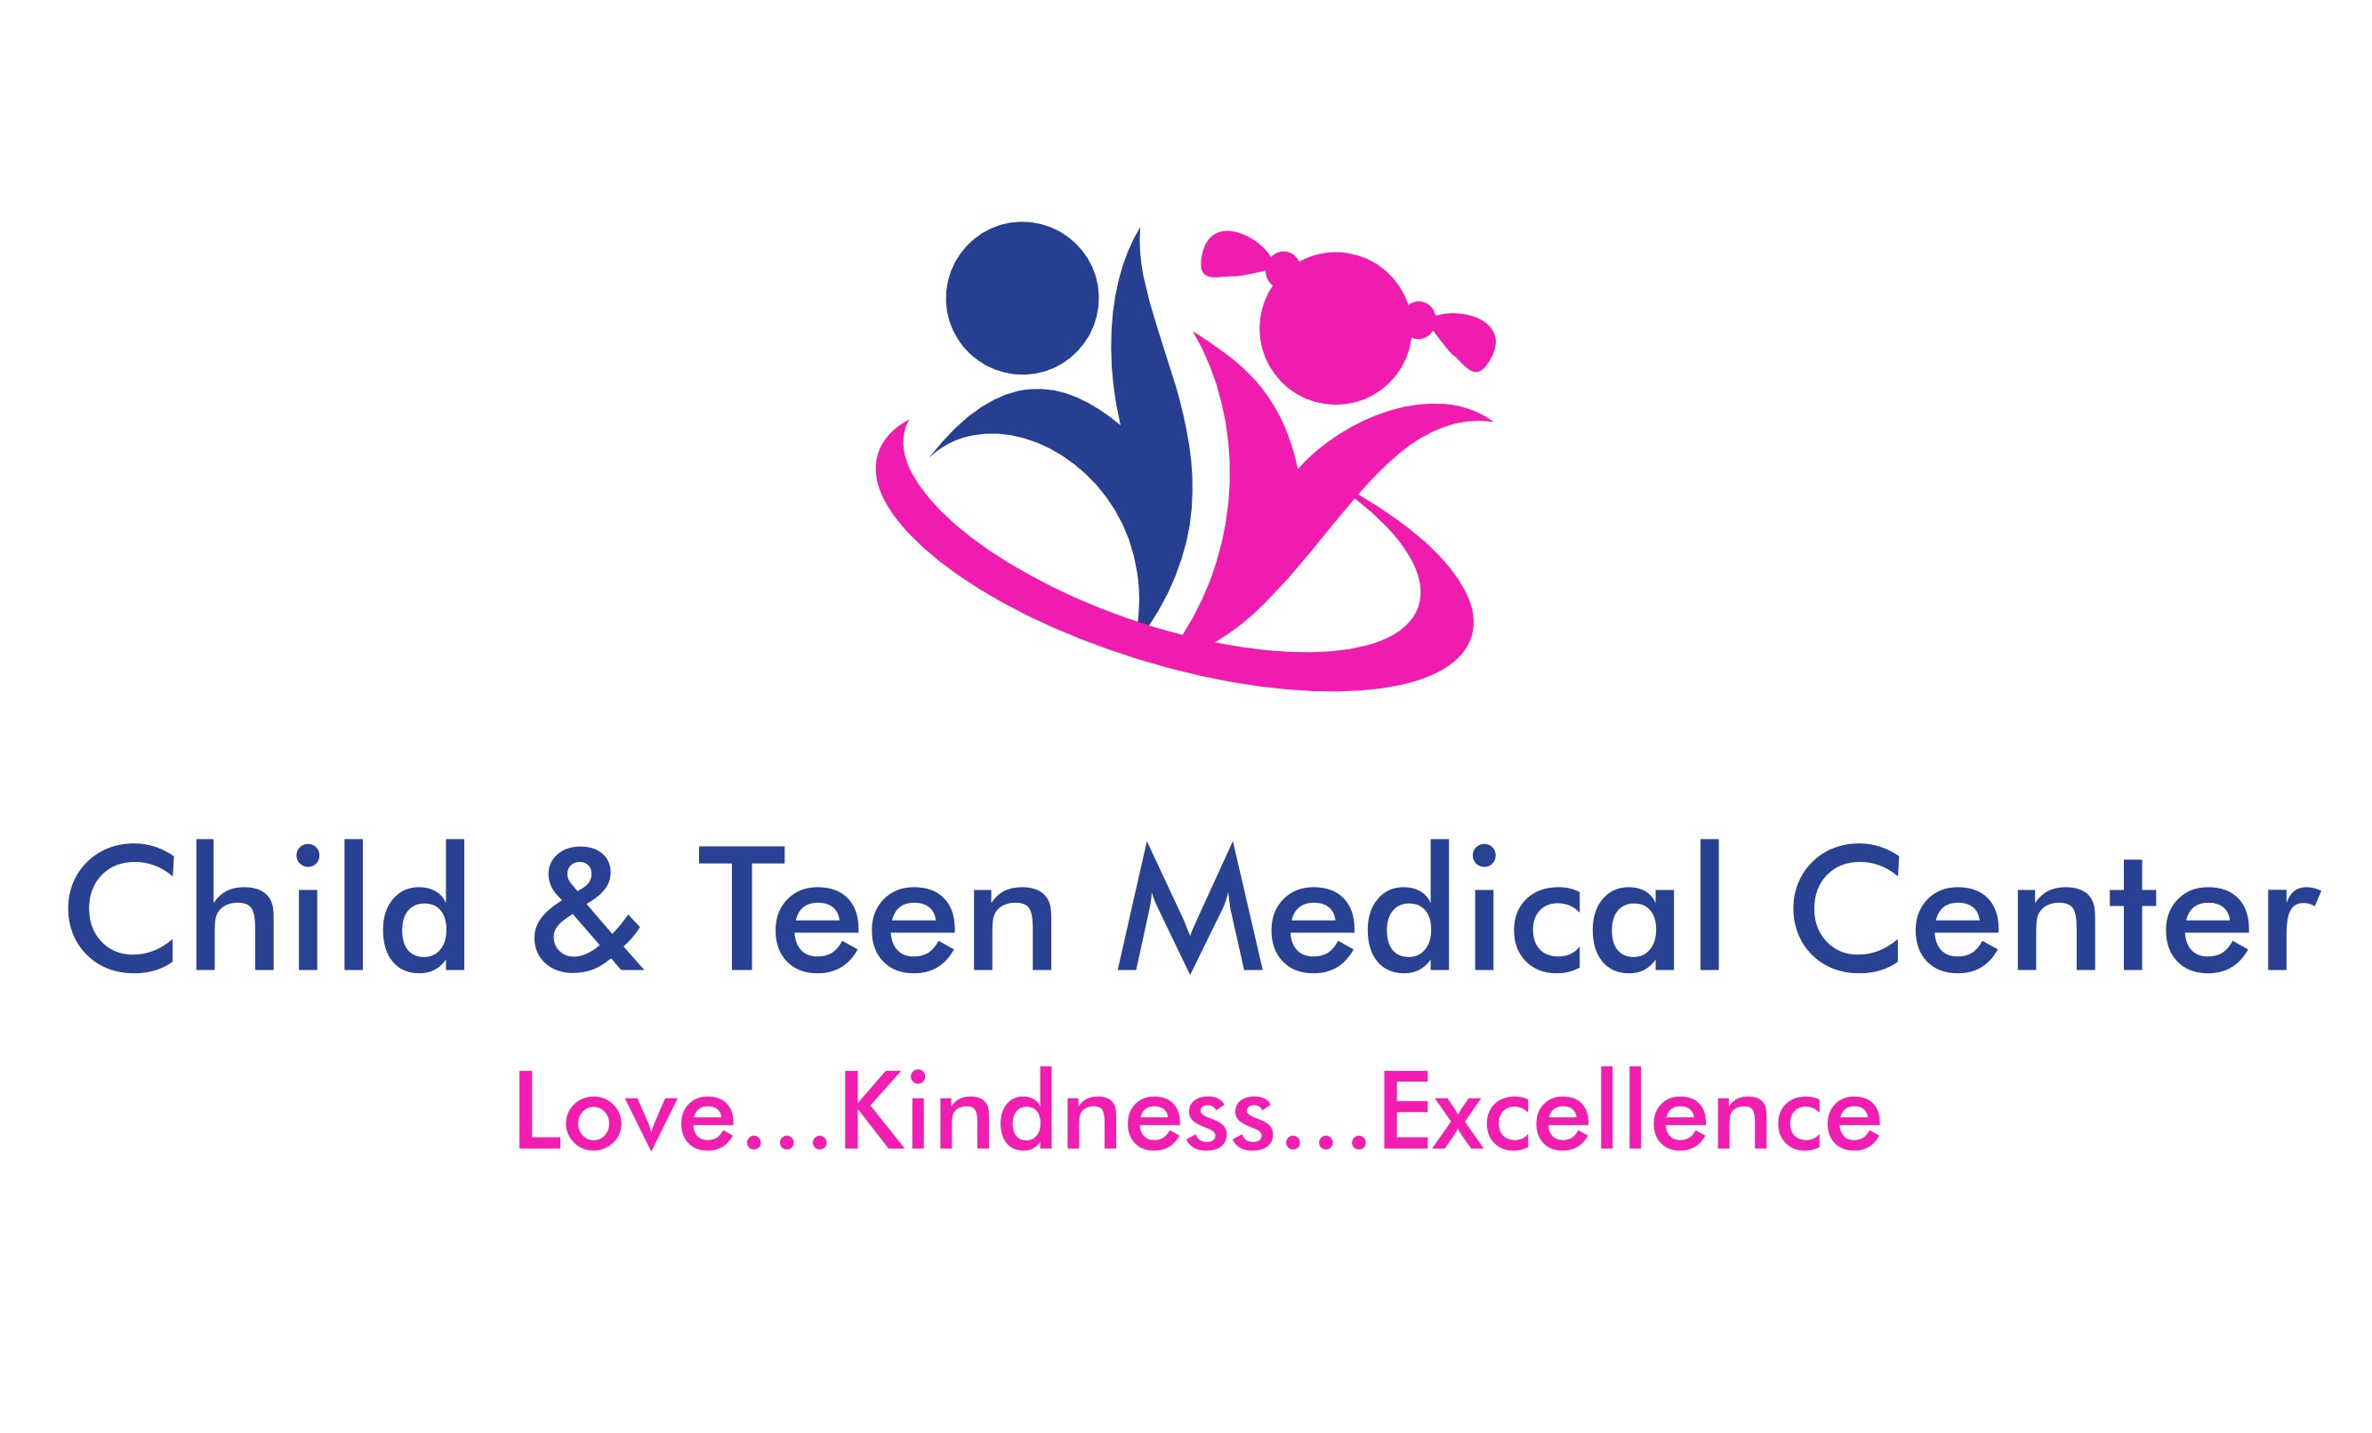 |  | FEver  A body temperature greater than 100.4 F. It is a symptom, not a disease. It can be measured under the arm, in the mouth, in the rectum or across forehead
Contact  PHONE:  763-333-7733  24-hour access to care  FAX:  763-333-7711  WEBSITE:  childandteenmedicalcenter.com  EMAIL:  info@childandteenmedicalcenter.com  LOCATIONS:  Blaine:  11107 Ulysses Street NE, Suite 100  Blaine, MN 55434  Fridley:  7225 University Ave NE  Fridley, MN 55432  PROVIDERS:  Kaylee Adams, CNP  Jennifer Benton, CNP  Catherine Chang, MD  John Hollerud, MD  Jennifer Rousseau, MD  Stephen Sitrin, MD  Benjamin Williams, CNP  Molly Wirtz, CNP |  | WHAT to Expect:  - Associated with a viral or bacterial infection. It is how the body fights illness  - Child will feel hot to the touch  - Can have chills or feel cold with fever onset  - Once fever breaks, patient will feel “hot” and sweat  - Fever can last for several days depending on illness  IMPORTANT TO KNOW:  - Fever does NOT always need to be treated, but you give medicine to help the child feel better  - Dress in light clothes and use a light blanket  - Give extra fluids (water or Pedialyte)  - Can place cool cloth to forehead or under arms  - Do not be concerned with the number, focus on reducing the fever  - With most illnesses, the child will be contagious for as long as the fever lasts  WHen to call the clinic:  - Temperature of 100.4 F or greater and less than 2 months old  - Fever lasting greater than 48 hours at any age  - Child is crying constantly or very fussy and not consoled  - Little energy, weakness  - Sleeping more and/or is difficult to wake up  - Neck pain or stiffness  - Poor intake or less wet diapers than normal  Medication Dosages for Current Weight ( )  Acetaminophen (Tylenol): every 4-6 hours  Ibuprofen (Motrin or Advil): every 6 hours

