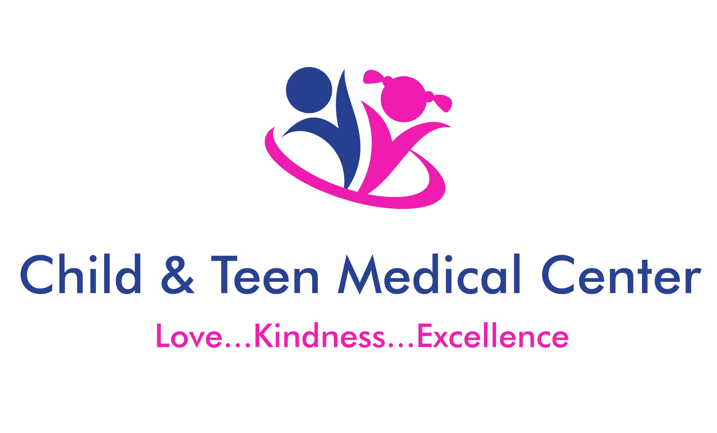 |  | Depression/Anxiety
WHEN TO SEEK EMERGENCY CARE:  People with depression/anxiety should go to the emergency room or call 911 if they are: having suicidal thoughts, thoughts of self-harm, or are a danger to themselves or others.  Contact  PHONE:  763-333-7733  24-hour access to care  FAX:  763-333-7711  WEBSITE:  childandteenmedicalcenter.com  EMAIL:  info@childandteenmedicalcenter.com  LOCATIONS:  Blaine:  11107 Ulysses Street NE, Suite 100  Blaine, MN 55434  Fridley:  7225 University Ave.  Fridley, MN 55432  PROVIDERS:  Kaylee Adams, CNP  Jennifer Benton, CNP  Catherine Chang, MD  John Hollerud, MD  Jennifer Rousseau, MD  Stephen Sitrin, MD  Benjamin Williams, CNP  Molly Wirtz, CNP |  | Crisis Assistance  - Call “**CRISIS” (**274747) from a cell phone or text MN to 741741  - Free help for those having a mental health crisis  - Canvas Health 24-hour Crisis Line: 763-755-3801  - University of Minnesota Riverside Emergency Department  - 2312 South 6th Street, Minneapolis, MN 55454  - Behavioral Emergency: 612-273-5640  - Behavioral Info: 612-672-6402  Local mental health providers  - Natalis Counseling and Psychology (see CTMC patients)  - Scheduling 763-333-7733  - Provider line for establish patients: 651-739-7539  - https://www.natalispsychology.com/  - Dr. Robert Van Siclen (See CTMC patients)  - Scheduling: 763-333-7733  - http://www.drvansiclen.com/  - Lee Carlson  - 763-780-3036  - https://leecarlsoncenter.org/  - Family Innovations  - 763-421-5535  - https://www.familyinnovations.com/  - Nystrom and Associates  - 763-284-3706  - https://www.nystromcounseling.com/  - Prairie Care  - 763-762-8800  - https://www.prairie-care.com/  what to expect  Patients diagnosed with anxiety and/or depression will need to be seen on a regular basis with a Child and Teen Medical Center (CTMC) provider. Depression/anxiety patients may also be referred to a mental health provider for psychological testing, on-going therapy sessions and/or complex medication management  Important to know:  Depression and anxiety can make it hard for you to deal with everyday situations. By using some of these self-care strategies, you can take some of the stress out of your life.  - Eat healthy. Eat a balance of protective, nutrient-dense foods. These foods include fresh fruits, vegetables, legumes, whole grains, lean meats, cold-water fish, eggs, low-fat dairy, soy products, nuts and seeds. Avoid processed and high sugar foods and drinks  - Drink plenty of water and limit caffeine intake  - Get plenty of rest (7-8 hours per night)  - Exercise 30-60 minutes daily (walking, biking, swimming, weightlifting, etc.)  - Shower/bathe regularly  - Disconnect from electronics and social media  - Engage in activities and/or hobbies that create happiness and promote creativity (color, journal, puzzles, paint, read a book)  - Volunteer or help someone in need  - See a mental health counselor on a regular basis  - Take depression/anxiety medications as prescribed by your provider  - Engage in relaxation activities (deep breathing, yoga, meditation)  Helpful stress relief/relaxation apps for android or iphone  - My3  - Calm-Harm  - Virtual Hopebox  - COVID coach  - Calm  - Insight Timer  - Moshi Twilight  - Stop, Breathe, Think app

